IQAC – SATYA INSTITUTE OF TECHNOLOGY AND MANAGEMENT
1.4.2 FEEDBACK ACTION TAKEN REPORT

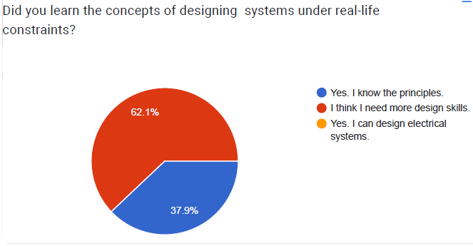

Action Taken:

- Open ended problems are posed to make the students think.
- Encouraged the students to participate in Community Service Projects.
- Arranged several industrial visits.

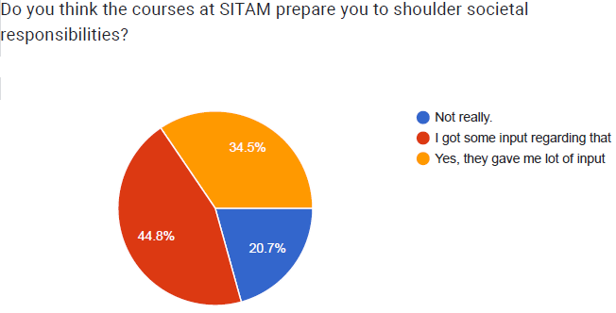

Action Taken:
- Included professional ethics and human values as a course
- Encouraged the students to do team work by assigning the some projects

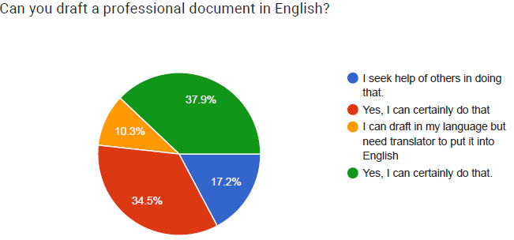

Action Taken:

- Conducted workshops in paper writing

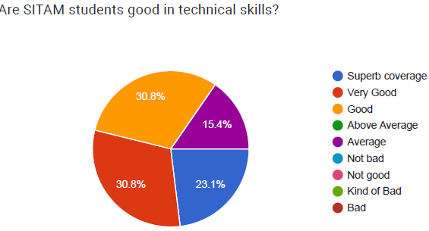

Action Taken:

  - Organized more workshops to improve the technical skills
  - Provided value-added courses as part of extra-curriculum activity

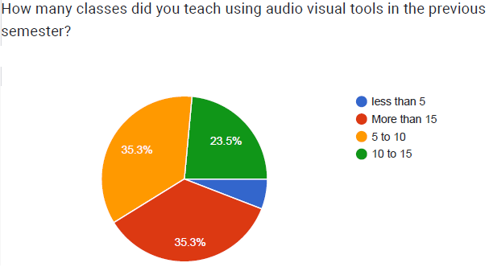

Action Taken
- Provided interactive digital boards

